Chapter 13, Solution 78.

We convert the reactances to their inductive values.

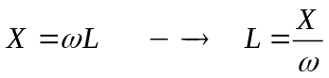
The schematic is as shown below.

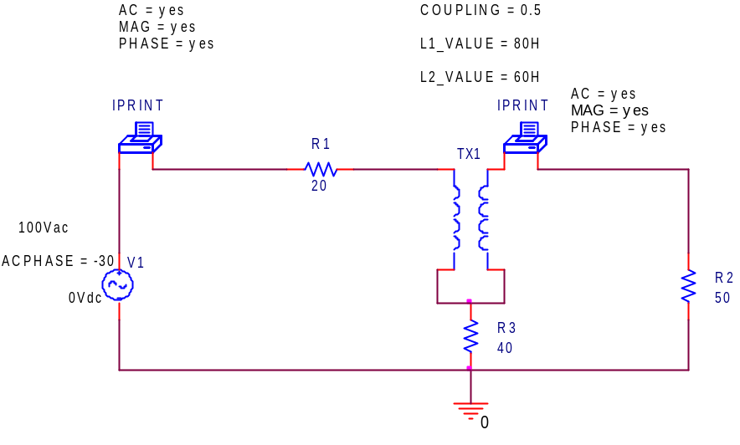

FREQ IM(V_PRINT1)IP(V_PRINT1)

1.592E-01 1.347E+00 -8.489E+01

FREQ IM(V_PRINT2)IP(V_PRINT2)

1.592E-01 6.588E-01 -7.769E+01

Thus,
I₁ = 1.347∠–84.89˚ amps and I₂ = 658.8∠–77.69˚ mA

